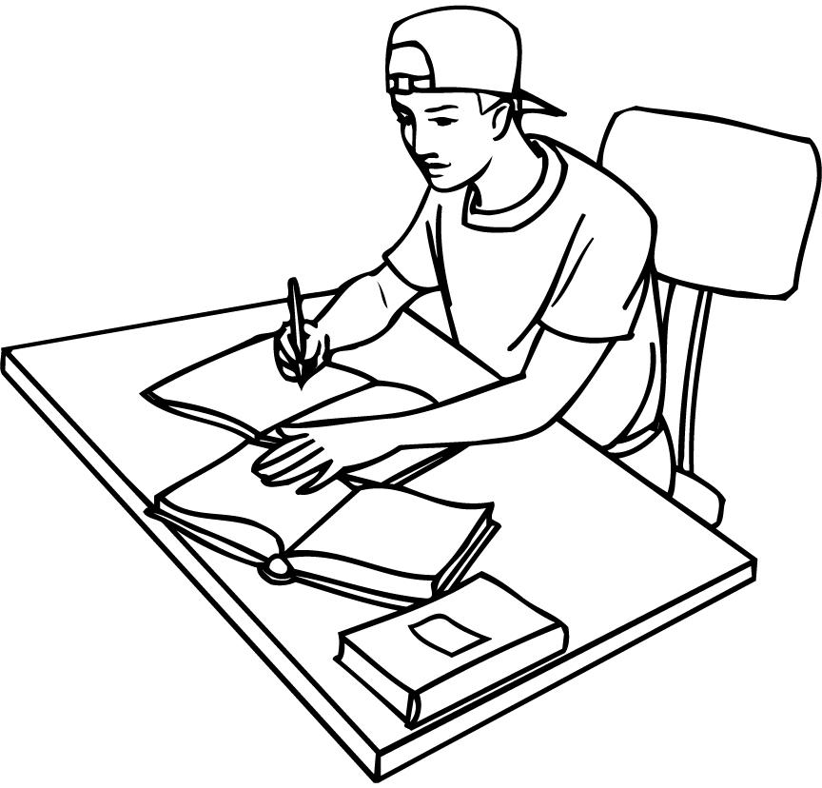

Be an Active Student

- Go to class. There is no substitute for being there – both mentally and physically.
- Get to know the professors and let them get to know you.
  - Clarify course content.
  - Go over exams.
- Get to know other students in your class.
  - Get phone numbers and e-mail addresses for at least 2 students in each of your classes.
  - Form a study group and meet regularly. Discuss material and quiz each other.
- Use Time Management Techniques.
  - Plan ahead. Use a schedule, calendar and a daily “to do” list.
  - Break down large tasks into small parts.
  - Use your “prime time” for study – a time when you are most alert.
- Know where you study effectively: home, library, study lounge, empty classroom, etc.
  - Remove distractions.
  - Know your attention span for study. Plan study sessions with that in mind.
- Know your learning style: visual, auditory, or tactile. Use your strengths to study effectively.
- Do the assigned reading before class.
  - Review each syllabus weekly.
  - Use a system for reading your textbooks.
- Use good note-taking techniques.
  - Study notes within 24 hours, before the next class, at the end of the week and several times before the exams.
- Prepare for exams.
  - Review materials repeatedly: the more you review, the more you remember.
  - Try to predict exam questions.
  - Review your old exams with your professor. Analyze what you did wrong and make a plan of study for the next exam.
  - Begin at least one week ahead to study for a major exam.

Use these tips to help you succeed!

